**** for English see below ***

Dear members, dear regional representatives, dear Unimog friends,

the first Unimog events are behind us and we hope that this situation will continue. All the meetings attended were a complete success after such a long dry spell. You could literally feel the enthusiasm among the visitors.

MEMBERSHIP MANAGEMENT
Thirty new members joined our association in July. The current membership is 7637; the highest membership number assigned is 11307 (as of 31.07.2021). One of the new members lives in Iceland, which means that the UCG is now represented in 44 countries.

NEWS FROM THE OFFICE

Holiday
The office will not be staffed from 04-22.08.2021 due to holidays.

New mobile phone number
The mobile phone number of the office has changed. From now on it is: 0152/55412763. The landline number (07222/8089938) remains the same.

75 Years of the Unimog
A myth celebrates its birthday! And we are part of it! Together with Mercedes-Benz Special Trucks and the Unimog Museum, we are planning and organising the two-day celebration to mark the 75th anniversary.
The parade, for which 180 members applied, will take place on 04.09.2021. The route (Wörth - Gaggenau) has already been "test driven" and preparations are in full swing at the weekly video conference with all participants. We would like to point out once again that the parking spaces around the museum will not be available for day visitors due to the construction work and the numerous exhibition vehicles. Please use the signposted parking spaces in the Bad Rotenfels industrial area. From there you can easily reach the museum on foot in about 10 minutes. Due to the demand for overnight accommodation in/on the Unimog, we are in the process of creating a limited number of parking spaces. As there are restrictions due to the current construction work around the museum, there are only a few sanitary facilities available. We kindly ask you to take this into consideration when possibly arriving by Unimog. The event is not a classic Unimog meeting, but merely an exhibition.

In the meantime, the shop of the Unimog Museum or Buch & Bild also offers merchandising articles (T-shirt, memory, mug) for the 75th anniversary. Take a look for yourself at:

https://www.buchundbild.de/de/Neuheiten

A special model will follow.

Technical training
Due to the current relaxed Corona situation, the postponed technical training courses on the U406_416, U403_413 could be held in cooperation with the Unimog Museum. But after the course is before the course! We are pleased to continue our training programme in October and therefore offer technical training courses on the U421 on the following dates:
04. - 05.10.2021
07. - 08.10.2021
11. - 12.10.2021
14. - 15.10.2021
18. - 19.10.2021
21. - 22.10.2021

Please find all information in the attachment. Due to holidays, registrations will only be possible from 23.08.2021 via info@unimog-club-gaggenau.de.

NEWS FROM THE BOARD

Strategy meeting
Finally we can develop our strategy further, because on 07.08.2021 the extended board will meet to work out various future topics.

Remodeling of the trailer and the Unimog
The trailer given to us by the regional group Göppingen/Stauferland was re-labelled a few months ago (we reported). Now the interior work could be continued. In the meantime the trailer is back from the carpenter and shines with a new wooden shelf. Here we now have the possibility to fill several plastic boxes with Clubshop goods and other supplies. A monitor has also been mounted on the wall so that films can be played. The Unimog was also equipped with a large shelf, matching boxes and merchandise, making Clubshop sales at events much easier. At the Weltenbummlertreffen, the new system could all be tried out for the first time and enjoyed great popularity.

25 years of membership
In June, 192 members received a letter of thanks with a certificate and PIN. The persons were honoured for 25 years of membership. We hope to have given everyone a little pleasure.

Cash audit
On 29.07.2021 the cash audit for the association year 2020 could be carried out. The auditors, Edgar Rost and Paul Westermann, were given an insight into the bookkeeping and were able to confirm that the cash management was impeccable.

MARKETING

The magazine continues to enjoy great popularity. The best way to read it is to enjoy it in the cool water. As our member Frank Priebe (UCG member number 827) impressively shows us here.

UNIMOG-MUSEUM

Museum open
The Unimog Museum can be visited without registration and without proof. As before, personal data must be left for tracing purposes and masks are also compulsory. It is also possible to take a ride on the outdoor course.

Raffle
Anyone who currently donates a brick can take part in the museum raffle. The prize is a ride in the parade (75 years of the Unimog - 04. + 05.09.2021), which is not for sale. A "ticket" costs 25,- €. And if you buy a golden brick, you will get 100 tickets for it in the "drum" and thus increase your chances of winning enormously. Please write us an e-mail after your donation to get into the lottery pot (info@unimog-museum.de). On behalf of the museum, we would like to thank all members who have so diligently supported the building project for the extension as a result of the appeal for donations in the last issue. We hope that the support will continue.

Highlights of the Museum
After the successful globetrotting meeting, we currently have a few small events coming up. The museum is taking part in the Gaggenau children's holiday fun and is offering the Gaggenau children who have stayed at home a programme all about the Unimog. At the NUFAM in Karlsruhe, as things stand today, the ramp will be there to provide thrills. The high-altitude world record vehicle will go on a factory tour of the "Stuttgart" plants and may also take part in the anniversary parade.

VISITED EVENTS

Speikboden
Around 60 Unimog crews from Germany, Austria, Italy and Switzerland attended the fourth South Tyrolean Unimog meeting in Sand im Taufers in mid-June. The meeting was a complete success, as the organisers once again offered a very appealing programme.
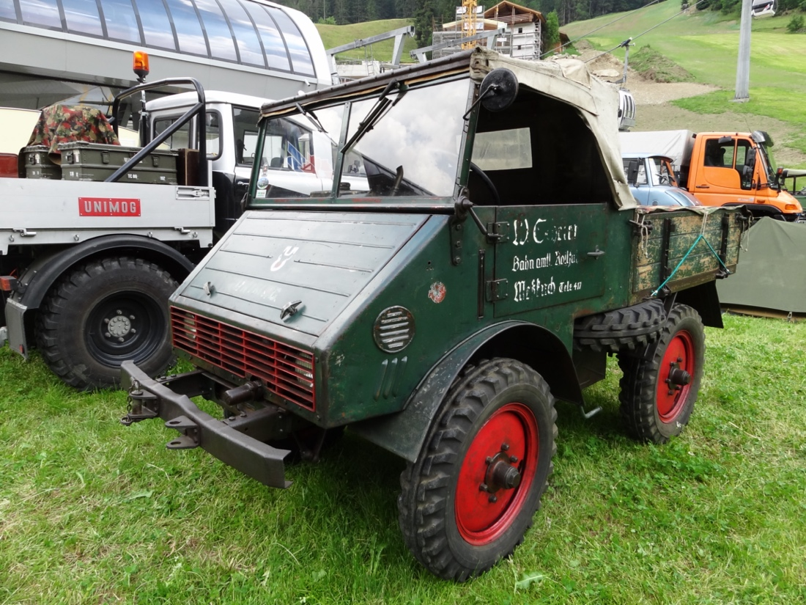
The oldest vehicle, Fabio Ponzi's Boehringer from 1949, drove 750 km to the meeting and back on its own axle.

Weltenbummlertreffen
The first big get-together of Unimog enthusiasts took place on the last weekend in August. More than 100 vehicles from globetrotters met in and around the museum over two days to exchange ideas and get new inspiration. Read more about it in issue`l 112.
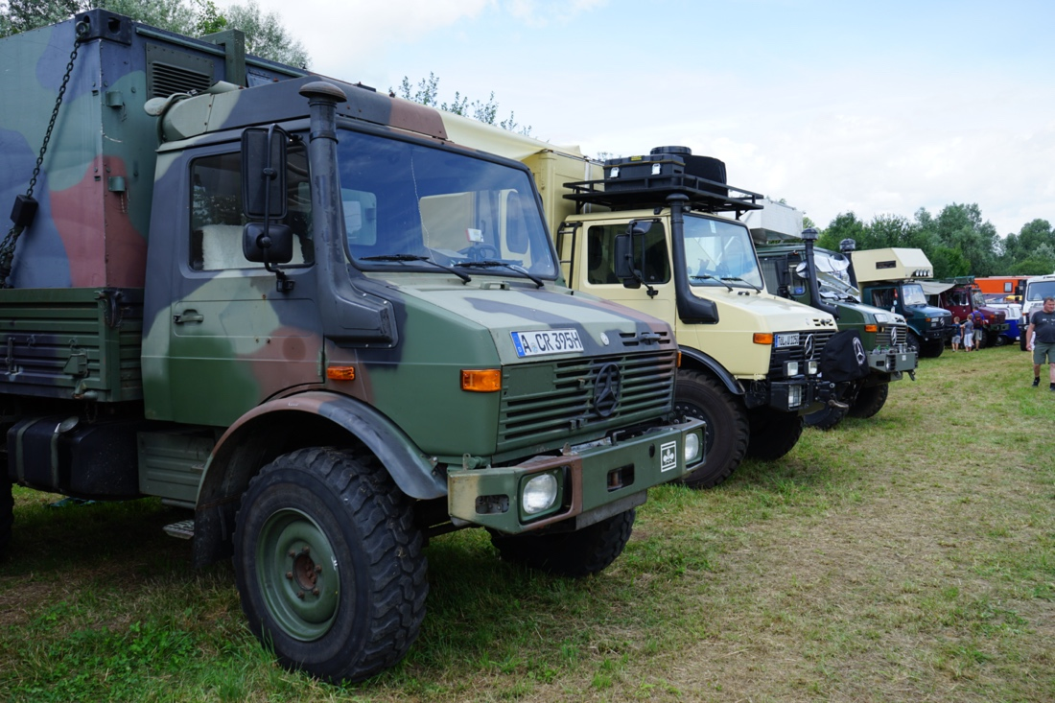
View of the meadow with the Unimog camper vans (Photo: Axel Otersen)

Classics & Coffee
On 01.08.2021, the Mercedes-Benz Museum in Stuttgart once again hosted the event "Classics & Coffee", formerly known as "Cars & Coffee".
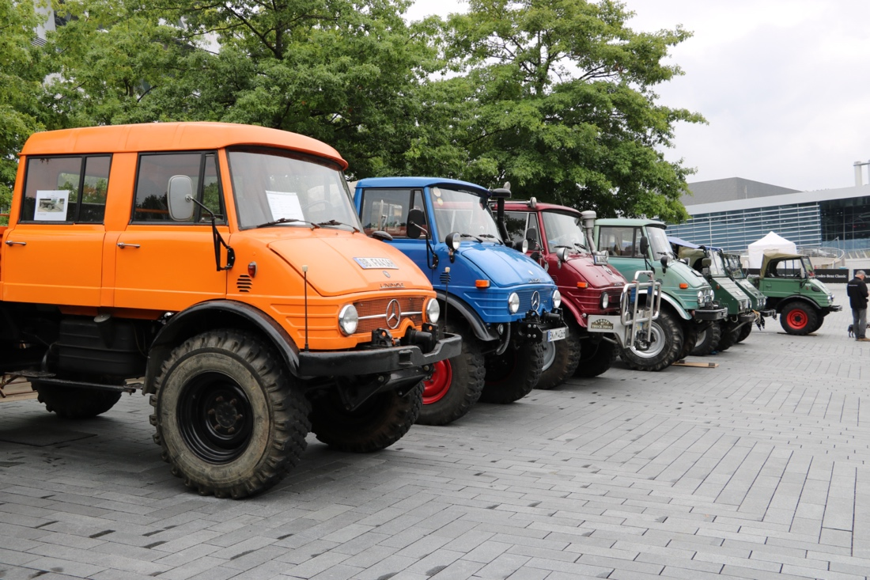
Despite the Weltenbummlertreffen as another event and unsettled weather, about 30 Unimogs found their way to the Mercedes-Benz Museum in Stuttgart. Many visitors and vehicle exhibitors also took the opportunity to visit the museum. A special eye-catcher was the Lesa 6x6 Unimog of Wolfgang M. from the Unimog Club Ostalb.
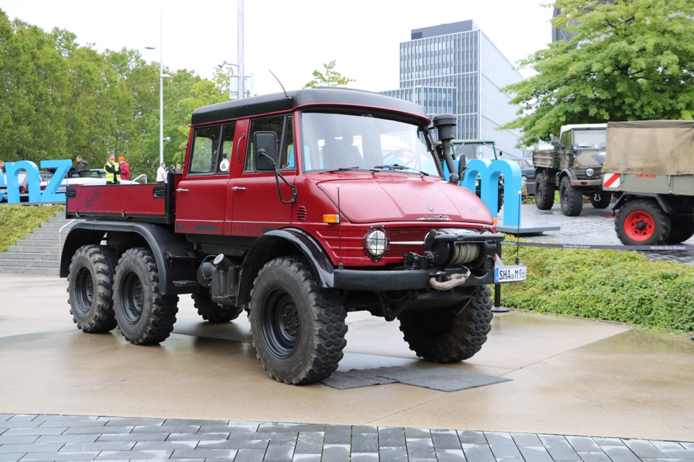
(Photo: Sonja Erhardt)

UPCOMING EVENTS

Annual Meeting Netherlands
Unfortunately, our annual meeting is now falling victim to Corona for the second year in a row, as we have to cancel the event planned in the Netherlands. The municipality has not given permission to hold it.

Mill birthday
The Geroldsauer Mühle in Baden-Baden will be 6 years old and would like to celebrate this with Unimog and their owners. The celebration will take place on Saturday, 21 August 2021 from 11:00 to 17:00 on the Sägmüller-Matte directly next to the Geroldsauer Mühle. Guests will be offered a variety of insights and impressions. In addition to the exhibitors, there will also be an extensive programme for the younger guests. If you are interested in exhibiting your vehicle around the mill on this day, you will receive a meal voucher as a thank you, including a drink for the pub. Registrations at saskia.ramin@geroldsauermuehle.de.

Meeting RG Mittelbaden in Malsch
Unfortunately the meeting planned in Malsch/Sulzbach had to be cancelled again. We hope it will work out at the third attempt next year.

CLUB-SHOP

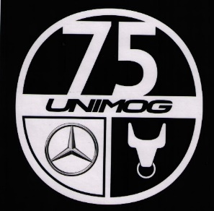
Orders in the Club Shop from now on will receive one of the newly arrived anniversary stickers with every order over 10 euros in merchandise value. So: Stop by and order online at: https://unimog-club-gaggenau.de/shop/

SCHEDULE PREVIEW 2021
(under reservation)

- 06.-08.08.2021 UVC-Meeting in Meinbrexen cancelled
- 21.08.2021 Mill birthday Baden-Baden
- 04.-05.09.2021 75 Years Unimog anniversary Unimog-Museum
- 10.-12.09.2021 UCG annual meeting Netherlands cancelled
- 17.-19.09.2021 Meeting RG Mittelbaden in Malsch/Sulzbach cancelled
- 30.09.-03.10.2021 Fair NUFAM in Karlsruhe
- 30.09.-01.10.2021 Regional representatives meeting inUnimog-Museum
- 02.10.2021 Parts market (in the morning in Kuppenheim) and
Member assembly (in the afternoon in Unimog-Museum)

Stay healthy! Yours sincerely, Your Board

